Activity 3. Master-Detail

# Setup

1. Open Xcode and select a new Master-Detail Application project

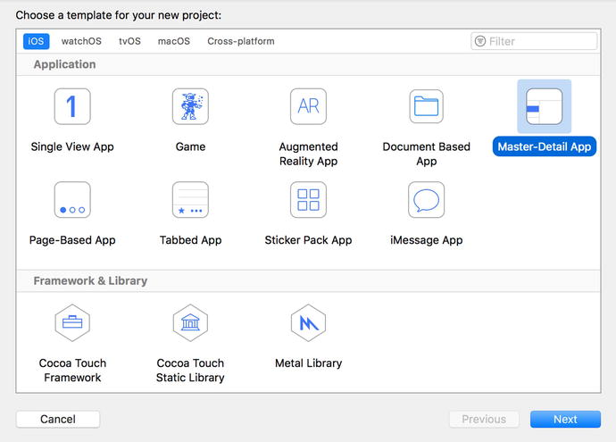

1. Create a project called BookStore. Save it in any folder
2. Click the plus (+) sign at the lower left of the screen in the Navigator area to add a new object to the project. Choose New File. Then choose the iOS section on the top and choose Swift File on the right

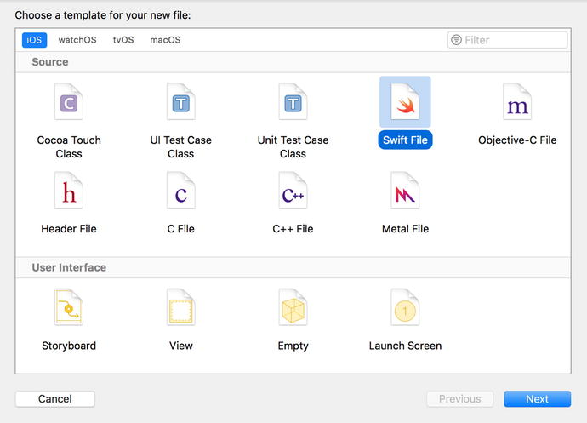

1. Create file named Book. Make sure the file is created in the BookStore folder of the project
2. Also create a file named BookStore
3. In the Book file, create the Book class and add the title, author and description properties

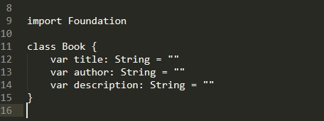

1. In the Main.storyboard file, select the Detail Scene
2. Remove the default label from the Scene
3. Modify DetailViewController to look like this

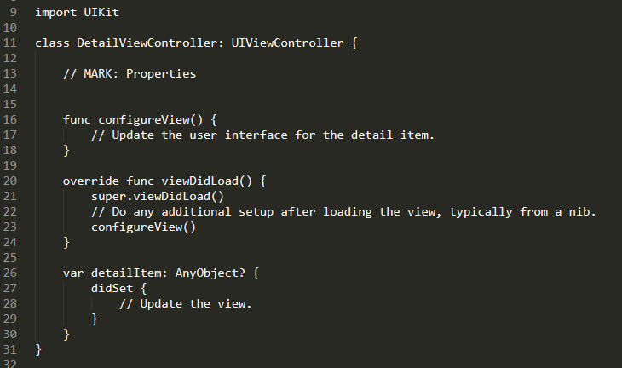

1. Add the following properties onto the Detail View

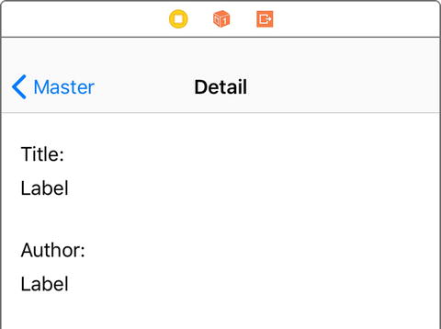

1. Add the properties in the DetailViewController

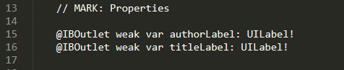

1. Add a description Label onto the Detail View and a Text View object

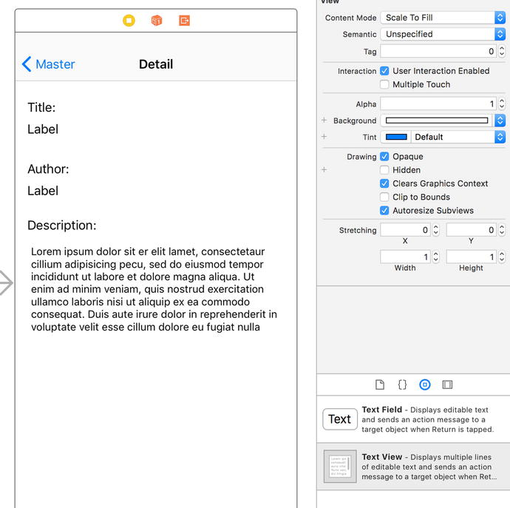

1. Create the outlet for the description text view.

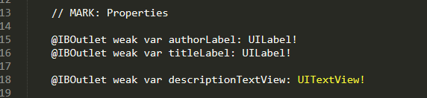

1. Create BookStore Data Model Class

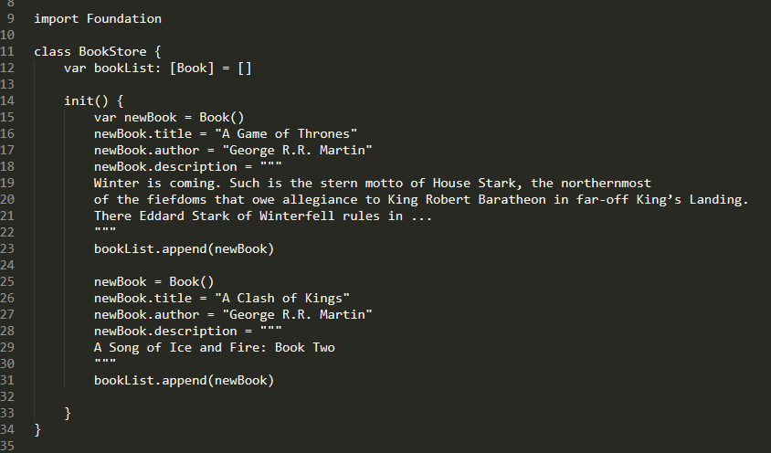

1. Add myBookStore variable in MasterViewController

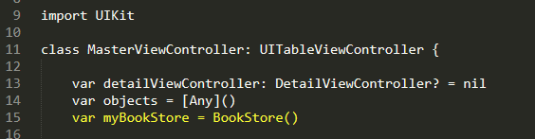

1. Modify the memberOfSections, and tableView methods in MasterViewController

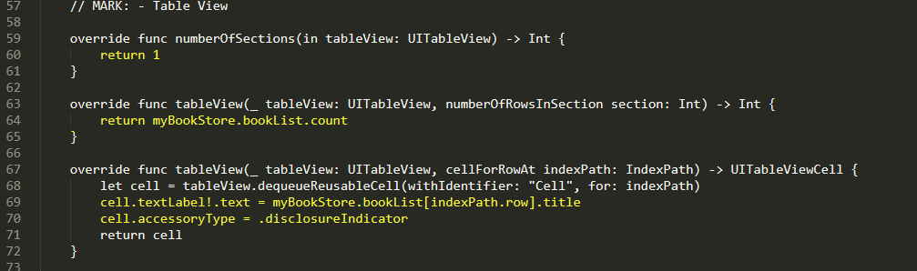

1. Test your application in the simulator
2. Modify the prepare method in MasterViewController

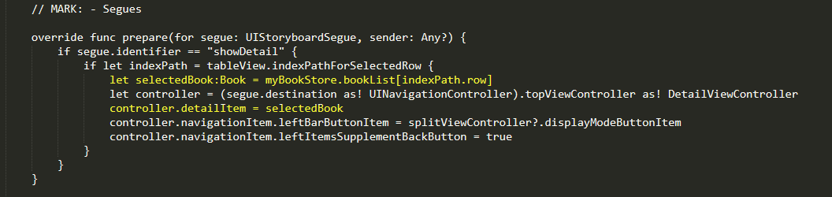

1. Modify the configureView method in the DetailViewController

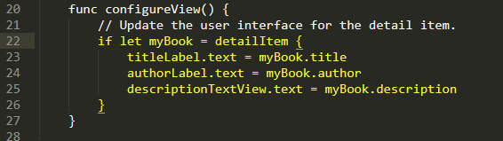

1. Modify the detailItem type

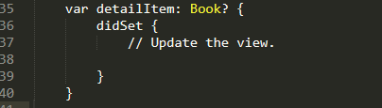

1. Test again

# Challenge

1. Add 3 more books to the bookstore using the original program as a guide.
2. Remove the Edit button on the Master Scene
3. Add another attribute to the Book class, make all the applicable changes
4. Change the colors of the app
5. Sort the books in the BookStore object so they appear in ascending order on the MasterDetailView.